[Featured](https://www.avantgardensne.com/gardenforeplay/?cat=3), [Garden Musings](https://www.avantgardensne.com/gardenforeplay/?cat=5), [Propagating & Pruning](https://www.avantgardensne.com/gardenforeplay/?cat=34)

**Collecting Seed for Seed Exchanges**

[October 27, 2014](https://www.avantgardensne.com/gardenforeplay/?p=4584) [Katherine Tracey](https://www.avantgardensne.com/gardenforeplay/?author=1) [1 Comment](https://www.avantgardensne.com/gardenforeplay/?p=4584#comments)

[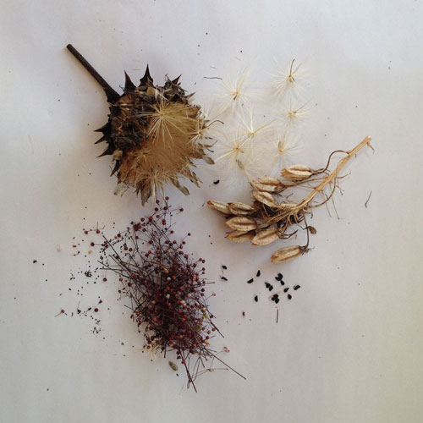](https://www.avantgardensne.com/gardenforeplay/?attachment_id=4585)

Clockwise from top left: Cynara cardunculus, Galtonia viridiflora, Talinum paniculatum

A few of the various Plant Societies which I belong to have seed exchanges, and I made a pledge to myself to get my seed collecting done, cleaned, sorted and packaged into little envelopes to meet this year’s deadline, which is usually **Nov 1**.  Time always has a way of getting ahead of you, so I was relieved to learn on the [**Hardy Plant Society’s webpage**](https://www.hardyplant.org/)that they have extended the deadline this year to **Nov 15**, and I can fill out the donation forms online and mail the seed in later! The [**North American Rock Garden Society**](https://www.nargs.org/seed-exchange) is not being so lenient; they want the list of seed being donated by **Nov 1st**, although they will allow a grace period until **Dec 1st** to package and send your seed in.

Yes, it does take time to process and save seed, but let me tell you why it is worth all the trouble. First, if you want to grow more of the plants, especially the annuals, which you enjoyed in your garden this year, why not collect the seed and save yourself a few dollars. Second, you may not be able to find a particular seed variety next year. I have found this true when it is an unusual variety that commercial growers do in limited numbers, or more likely their source dried up or had a crop failure. Third, you are bound to collect more seed that you can use, so why not share the bounty by participating in a seed exchange? Most seed exchanges work this way: You become a member of the group, such as the [**Hardy Plant Society**,](http://hardyplant.org) which collects and pools the seed, then makes the seed available to its membership at a very inexpensive price ($.50). A big plus: seed donors get first dibs at the selection,  and get to select an extra 10 packets for their efforts. Groups like the [**Seed Savers Exchange**](http://www.seedsavers.org) allow you to purchase seed without becoming a member, but membership has its perks.lots of information, discounts and member’s only offerings, plus you’re supporting an important organization.

There’s a lot to know about collecting seed, but it is beyond the scope of this blog post to get into a lot of detail.  Besides, there is so much information now on the internet that you no doubt will find answers to particular seed questions in a web search. I just want to pass on some basic tips.

* Collect seed on a sunny dry day. Wet seed pods can harbor spores which may encourage mold and spoil the seed.
* Label your seed correctly, especially if you plan to donate to a seed exchange.
* If you grow several varieties of certain plants and they are within close range of each other (for example: several different forms/colors of zinnias) your seed will not come true to type. You may get some interesting variations and colors, but you should label it as such. Also, seeds from most F1 Hybrids will not come true.
* Watch seed pods daily for maturity. You want to capture them just before they explode all over your garden.
* Store the seed in paper bags in a dry spot until you have time to clean and sort.
* Separate the chaff from the seed when packaging.

Here are  links for more information on joining a few Plant Societies.

[**The Hardy Plant Society–Mid Atlantic Group**](http://hardyplant.org)

[**The Hardy Plant Society–UK**](http://www.hardy-plant.org.uk)

[**North American Rock Garden Society**](https://www.nargs.org)

[**The Seed Savers Exchange**](http://www.seedsavers.org)